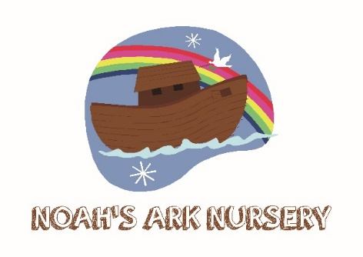
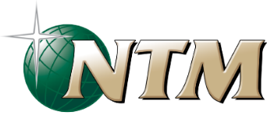

Consent form for children ages 4 and below attending Noah’s Ark nursery during NTM Make a Difference Conference 19th – 21st June 2020

Child’s Full Name:
Name Known by:
Date of Birth: First Language:
Parents/ Guardians Name:
Mobile Phone:
Address

Special Dietary Requirements:

Details of any current medication, conditions, allergies, disabilities etc. (e.g Asthma inhalers etc)

I give permission for (child’s name) to take part in the normal activities of this group. These activities will take place between the hours of 9.20 am and 12.30 pm on Saturday 20th and Sunday 21st June 2020. I understand that while involved he/she will be under the instruction and care of the group leader and other adults approved by the NTM leadership and that while the staff in charge of the group will take all reasonable care of the children, they cannot necessarily be held responsible for any loss, damage or injury suffered by my child during, or as a result of, the activity.

Whenever medical advice or treatment is needed, the assistance of a GP or A&E Department of a hospital will be sought. The Children Act 1989 allows a doctor to provide any necessary treatment by doing ‘what is reasonable in all the circumstances of the case for the purpose of safeguarding or promoting the child’s welfare’.
I understand:
- Every effort will be made to contact me as soon as possible should my child become ill or have an accident.
- My child will be given medical/dental treatment as necessary.

Signed: (parent/or adult with parental responsibility)

________________________________________

Date: _________________________________________

